Name: Period: Due Date: May 6, 2019

(MATH 4/5)
Exponentials & Logarithms Homework #11

Directions: Graph the transformation and describe each of the transformations.

Domain
Range
Asymptote
X-Intercept
Y-Intercept
End Behavior
Interval of Increase/Decrease
- g(x)= - ½ f(x)+1
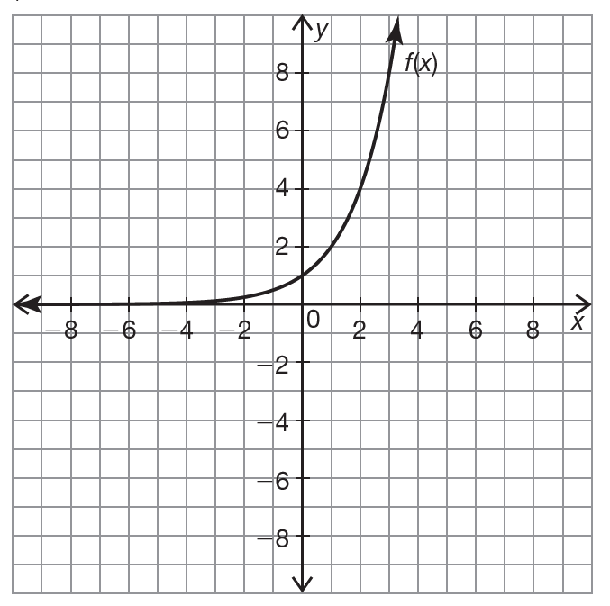

f(x) was _________________________

________________________________

____________________ to obtain g(x).

Directions: Graph the logarithmic function and find the key characteristics. (You can count the lines by whatever you would like; example 5, 10, 15, 20, etc.)

- f(x)=log₅x

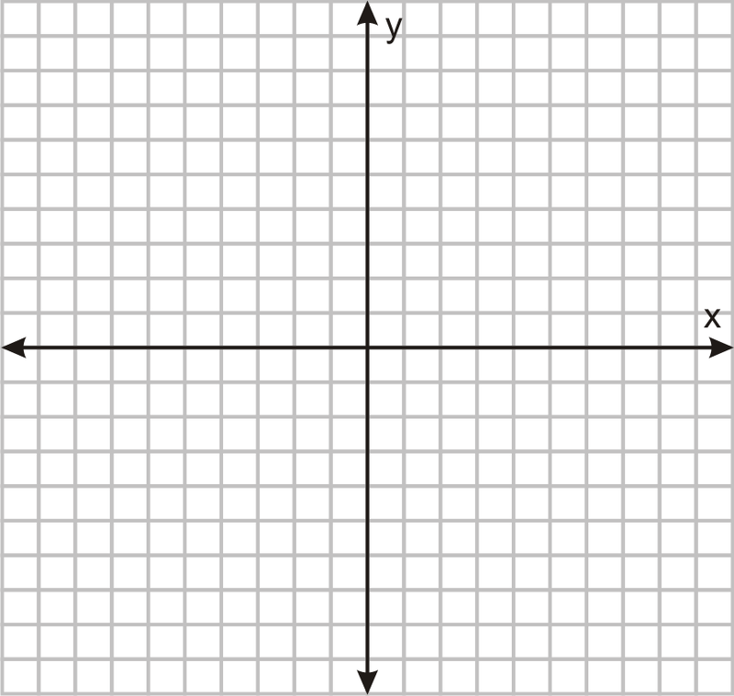

Domain
Range
Asymptote
X-Intercept
Y-Intercept
End Behavior
Interval of Increase/Decrease

Directions: Solve for x.

- log₂x=5

- log_{x}81=2

- log₃27=x

- log₅x=3

Directions: Graph the transformation and describe each of the transformations.

- n(x)=m(-x+1)-2
Domain
Range
Asymptote
X-Intercept
Y-Intercept
End Behavior
Interval of Increase/Decrease
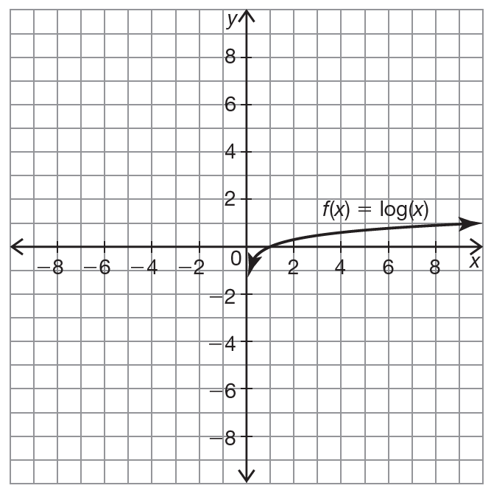

m(x) was _________________________

________________________________

____________________ to obtain n(x).

Directions: Solve for x.

- log₇(343)=x

- log _{¼} (64)=x

