Name: Period: Date:

Friday Quiz #9 (Math 5)

- Graph the exponential function and find the range and end behavior.
$$f\left(x\right)={\left(\frac{1}{2}\right)}^{x}$$

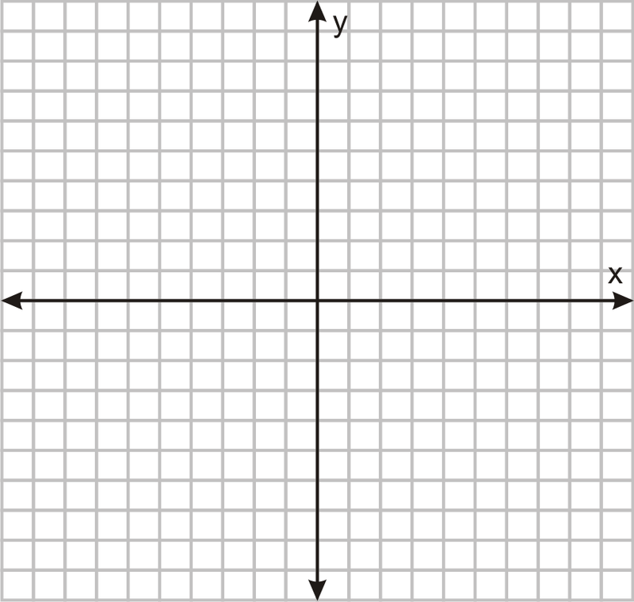

Range: ______________________

As x→∞, y→_____.

As x→-∞, y→_____.
- Joseph put $1000 into a bank account after his first paycheck at his job as an accountant. The bank offers 4% interest compounded quarterly. How much will be in his bank account after 10 years?

Name: Period: Date:

Friday Quiz #9 (Math 5)

- Graph the exponential function and find the range and end behavior.
$$f\left(x\right)={\left(\frac{1}{2}\right)}^{x}$$

Range: ______________________

As x→∞, y→_____.

As x→-∞, y→_____.
- Joseph put $1000 into a bank account after his first paycheck at his job as an accountant. The bank offers 4% interest compounded quarterly. How much will be in his bank account after 10 years?

